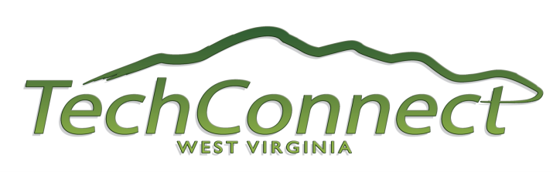

FOR IMMEDIATE RELEASE

CONTACT:
Anne Barth Dr. Karel Schubert
TechConnect West Virginia Bioscience Association of West Virginia
304-444-2918 304-678-4139

Growth of WV Bioscience Industry Focus of Benedum Grant Award

Charleston, WV [DATE] – TechConnect West Virginia and the Bioscience Association of West Virginia have received grant funding from the Claude Worthington Benedum Foundation to assist the organizations in their missions to grow the bioscience sector in West Virginia, organization representatives announced today.

The grant will be used to implement key goals and action items outlined in TechConnect West Virginia’s Blueprint for Technology-Based Economic Development Biotechnology Report. TechConnectWV commissioned the study, which was conducted by the Battelle Technology Partnership Practice and issued in January 2011.

“We are greatly appreciative of the Benedum Foundation for their willingness to put their resources towards this very important goal of growing the research-based bioscience industry in West Virginia,” said Anne Barth, executive director of TechConnectWV. “This grant will help spur collaboration between our universities and the private sector leading to an increase in research dollars, private sector commercialization and economic impact for the state.”

The Bioscience Association of West Virginia (BioWV), in partnership with TechConnectWV, will utilize the grant funding to implement four major strategies of the Biotech Blueprint:

- Create the face of the biosciences in West Virginia;
- Advance the bioscience technology cluster;
- Develop a skilled bioscience workforce;
- Enhance the infrastructure to encourage entrepreneurship and assist start-up companies.

Dr. Karel Schubert, executive director of BioWV, said, “This far reaching grant will help us grow membership in our Association, develop programs to advance bioscience companies and promote industry-academic collaborations, and provide internship opportunities for college students at West Virginia companies. We are thankful for Benedum’s involvement in this initiative and believe it will result in a more vibrant and diversified economy for the Mountain State.”

About TechConnectWV
TechConnectWV is a non-profit coalition with broad representation from private industry, the public sector, and higher education. TechConnectWV works to enhance awareness, spur collaboration, and raise the discussion of issues surrounding technology-based economic development. Its goals are to diversify the state’s economy, promote economic prosperity, and create high-paying jobs. For more information, visit www.techconnectwv.com.

About BioWV
The purpose of the Bioscience Association of West Virginia is to promote and strengthen the bioscience industry in the state by developing a cohesive community that unites biotechnology, pharmaceutical, medical device and research organizations. To advance this mission, BioWV provides educational, networking and commercial opportunities for its members, and serves as an educational and information resource to advance public understanding about the bioscience industry. For more information, visit www.biowv.org.

For additional information, contact Karel Schubert at 304-678-4139 or karel.schubert@biowv.org.

# END #

