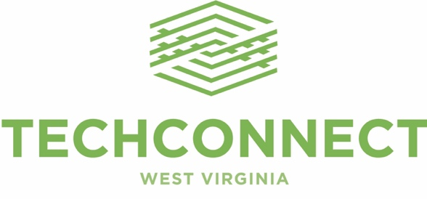

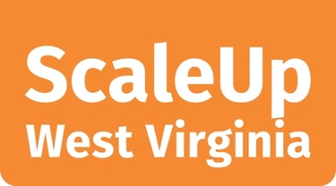TechConnectWV recently launched ScaleUp West Virginia, a program designed to help West Virginia companies develop new products and technologies and move them to market; support small manufacturers in adopting advanced tools and processes; and promote increased entrepreneurial activity in our state. The program targets 40 counties, including many that have been particularly affected by the loss of mining jobs, as well as jobs directly related to the mining industry.

ScaleUp West Virginia is made possible through a partnership involving TechConnectWV, the U.S. Economic Development Administration (EDA), and the State of West Virginia. A total of $710,000 is available to assist West Virginia companies and entrepreneurs through the ScaleUp WV program’s service partners and their initiatives. Service provider partners and initiatives include:

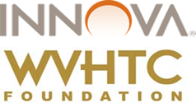**INNOVA Commercialization Group**

Location: West Virginia High Technology Foundation, Fairmont

Initiative: ScaleUp WV Venture

Services include opportunity validation, proof of concept/prototype development, developing management structure, and early-stage funding.

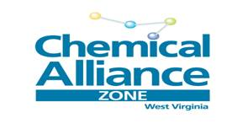

**Chemical Alliance Zone (CAZ)**

Location: West Virginia Regional Technology Park,

South Charleston

Initiative: ChemAssist

Services include general technology and commercialization consultation and guidance; economic analysis; estimates and assistance; IP evaluation and assistance; marketing and competitor evaluations and assistance; lab and pilot plant assistance; proof-of-concept studies and evaluations; sample production for customer and marketing testing; and engineering evaluations and assistance.

**Center for Applied Research &Technology (CART)**

Location: Bluefield State College, Bluefield

Initiative: ScaleUp WV Design for Manufacturing

Services include technology and engineering roadmaps; systems engineering and integration; technology concept refinement; and lab support.

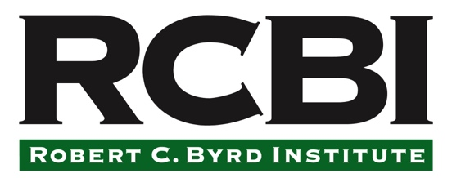

**Robert C. Byrd Institute for Advanced Flexible Manufacturing (RCBI)**

Locations: Huntington, South Charleston and Bridgeport

Initiative: ScaleUp WV Advanced Manufacturing

Services include 3D printing support; prototyping; reverse engineering; computer-controlled production equipment; workforce development and training; quality management initiatives.

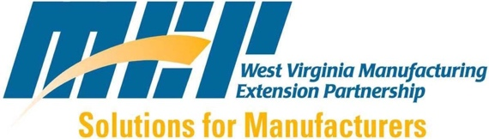**West Virginia Manufacturing Extension Partnership (WVMEP)**

Location: West Virginia University, Morgantown

Initiative: ScaleUp WV Transformational Manufacturing

Services include assessment of operational effectiveness; development of new market and customers; innovations within current product lines; new product and application development; new business partnership and venture development; export market development; strategies for responding to declining market conditions; supply chain support; and IP and technology transfer.

**Promoting Entrepreneurship**

To help promote increased entrepreneurial activity in West Virginia, TechConnectWV is working with post-secondary education providers, the U.S. Small Business Administration and other partners on local events designed to spur awareness of opportunities and resources available to potential entrepreneurs, especially within our state’s women and minority communities.

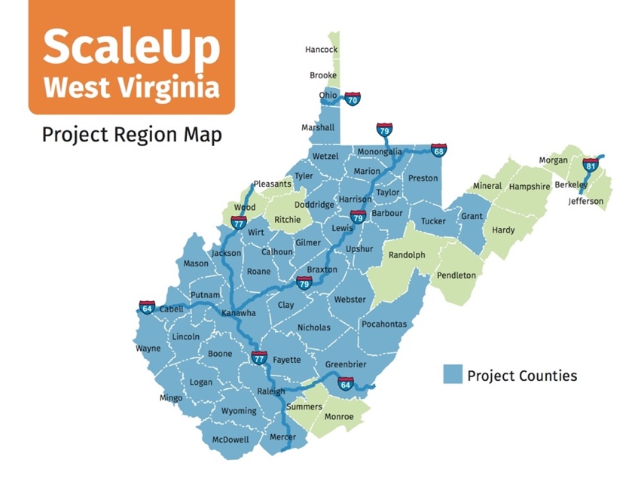

*ScaleUp West Virginia is a part of TechConnect WV’s leadership in helping to create a more diverse, vibrant economy in West Virginia and, ultimately, new job opportunities for West Virginians.*

***For more information on TechConnect West Virginia, ScaleUp West Virginia, and other***

***TechConnect West Virginia programs, visit http://techconnectwv.org/innovation/programs/****.*